|  |
| --- |
| Name:  **S O Perera** |
| Student Reference Number: **10707315** |



|  |  |  |
| --- | --- | --- |
| Module Code: **PUSL3108** | Module Name: **Pervasive Computing** | |
| Coursework Title: **Pervasive Computing Coursework** | | |
| Deadline Date: **15th May 2022** | | Member of staff responsible for coursework: **Dr. Craig Barnyard** |
| Programme: **BSc (Hons) Plymouth Software Engineering** | | |
| Please note that University Academic Regulations are available under Rules and Regulations on the University website [www.plymouth.ac.uk/studenthandbook](http://www.plymouth.ac.uk/studenthandbook). | | |
| Group work: please list all names of all participants formally associated with this work and state whether the work was undertaken alone or as part of a team. Please note you may be required to identify individual responsibility for component parts.  **G.M.D.D. Ratnayake – 10707351**  **S.O. Perera – 10707315**  **J.A. Mujeeb – 10707284**  **N. S. De Alwis – 10707160**  **M. D. A. Medhavi – 10707278**  **P. P. L. Dilhani – 10709402**  ***We confirm that we have read and understood the Plymouth University regulations relating to Assessment Offences and that we are aware of the possible penalties for any breach of these regulations. We confirm that this is the independent work of the group.***  Signed on behalf of the group: **S O Perera** | | |
| Individual assignment: ***I confirm that I have read and understood the Plymouth University regulations relating to Assessment Offences and that I am aware of the possible penalties for any breach of these regulations. I confirm that this is my own independent work.***  Signed: | | |
| Use of translation software: failure to declare that translation software or a similar writing aid has been used will be treated as an assessment offence.  I *have used/not used translation software.  If used, please state name of software………………………………………………………………… | | |
| **Overall mark _____% Assessors Initials ______ Date_________** | | |

*Please delete as appropriateSci/ps/d:/students/cwkfrontcover/2013/14

|  |  |  |
| --- | --- | --- |
| Name | Student ID | Contribution |
| J.A. Mujeeb | 10707284 | 16.7% |
| G.M.D.D. Ratnayake | 10707351 | 16.7% |
| S.O. Perera | 10707315 | 16.7% |
| N. S. De Alwis | 10707160 | 16.7% |
| M. D. A. Medhavi | 10707278 | 16.7% |
| P. P. L. Dilhani | 10709402 | 16.7% |

**Part A**

* 1. **Electronic Toll Collection System (ETC)**

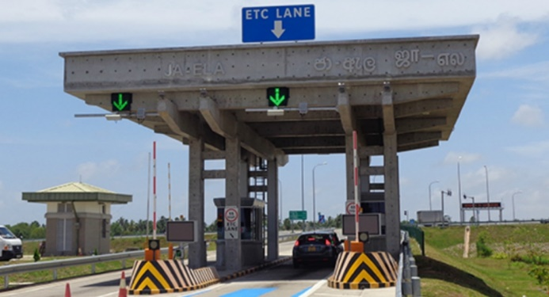

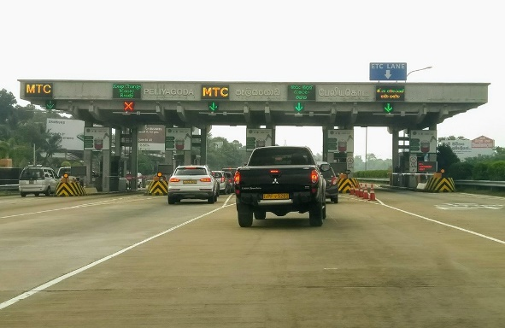

An Electronic Toll Collection System is a service that permits the operation of an automatic cashless toll fee collection for vehicles to use bridges, tunnels, lanes or roads. It is a more prolific alternative than commonly generic toll booths.

In Sri Lanka, those that wish to utilize the ETC Systems are required to get registered. Once completed, they will receive a small card. With this card, the user will have permission to utilize ETC lane. Once a vehicle passes through an ETC tollgate, a signal will be sent to the card. The card will gather the vehicle’s number plate information, along with the remaining card balance. Once a vehicle reaches the exit, it will arrive at another tollgate. This tollgate will detect a signal and immediately check the vehicle category and identification. Subsequently, a price deduction calculation will be performed and the remaining balance along with the vehicle number will be displayed on an LED screen near the tollgate. Customers are able to automatically disburse the toll fee, where the payment is electronically debited from the account of the car owner. The toll gates to automatically open, eradicating the necessity of having to halt and perform manual remuneration while passing the toll gate.

**1.1.1 Discussion -**

* ETC Systems in Sri Lanka are rapidly ameliorating the transportation industry by successfully substituting conventional toll booths. This stratagem has become a bedrock for innovation, leveraging an increase in throughput and anchoring in congestion management. ETC lanes usher in a substantially eminent increase in capacity in comparison to manual and automatic coin machine lanes. Not only are ETC Systems effusively cost effective, but also notably increase the average vehicle throughput compared to normal toll booths. Subsequently, this plays a part in alleviating the reduction of expressway traffic congestion with the adaptment of electronical user fee collection. It is proclaimed that its overall usage aids in the improvement of environmental conditions as it decreases emissions. As a result, this system has globally transformed the way that vehicles are driven and designed by reconstituting the driving experience with technology. Furthermore, they are majorly cost-effective, due to curtailed amount of operational and maintenance expenses compared to manual lanes.

,

**The shortcomings:**

* The receiver of the ETC tollgate is allotted in a high area, meaning that it would receive signals of taller vehicles first. If we consider a scenario where an automobile as large as a bus was situated behind a smaller vehicle, the ETC tollgate would scan the card of the bus before scanning the card of the car. Within that time span, it is ostensible for the smaller vehicle to quickly leave without performing the payment transaction. In congruence, this may result in the bus having to unnecessarily pay twice. It is apparent that ETC Systems may not perform at its optimum effort in circumstances when vehicles do not maintain a specified distance between each other. Moreover, it is mandatory for all automobiles to maintain a particularized distance in pursuance of enabling the system to work smoothly. Without the specified distance sustained between vehicles, it is feasible for ETC Systems to not perform at its optimum effort.

**The strengths:**

* The implementation of ETC Systems have exuberantly abetted the reduction of time wastage in highways. In generic toll booths, users are permitted to provide a remuneration in order to access the highway. According to litigable insights, in ETC Systems, only a time span of 2 seconds is engaged in order to acquire a proper reading, and get the system to display the details in the LED screen for the user to see and receive a confirmed payment. The process of physically rendering payments to the counter would enact long queues. With the effectuation of the ETC lane, the queues are abundantly reducing. Once a person has signed up for the option of using the ETC lane, they do not have to wait in queues and waste time, they can just pass through the tollgate within seconds. In vehicles, speed acceleration, deceleration and halting can incite extra fuel consumption. As ETC System’s permit the parallel functions of vehicles passage and toll collection, the reduction of fuel consumption has become attainable. This would also aid in the interests of saving time. When it comes to cost benefits that are in tandem with the utilization of ETC Stations, the same number of employed personnel is not required in comparison to traditional tollbooths. As a result, a significant drop in expenses is exhibited because of the savings acquired with the elimination of ticket dispensation and manpower. This would inevitably contribute towards the reduction of costs.

**Two possible improvements:**

* It is indisputably evident that there are insufficiencies in relation to faultless vehicle scanning. As previously indicated, there is a possibility for certain vehicles to vacate without performing the required payment transaction. This can metamorphose into a dire complication. It would be deemed unethical and unfair to those who are rightfully paying to use ETC facilities. As these problematic insufficiencies have been rectified in ETC Systems situated abroad, the inadequacies related to ETC Systems in Sri Lanka must also be improved.
* ETC System users are usually unable to remember the exact balance remaining in their ETC card. As a consequence, users may prospectively try and utilize the system with an inadequate amount of credit. This may lead to traffic congestion in the ETC lane. ETC lane is a lane that should be kept free at all times for users to pass through without any challenges. As a solution, it would be beneficial for ETC System users to be notified as soon as their card balance becomes incommensurate.

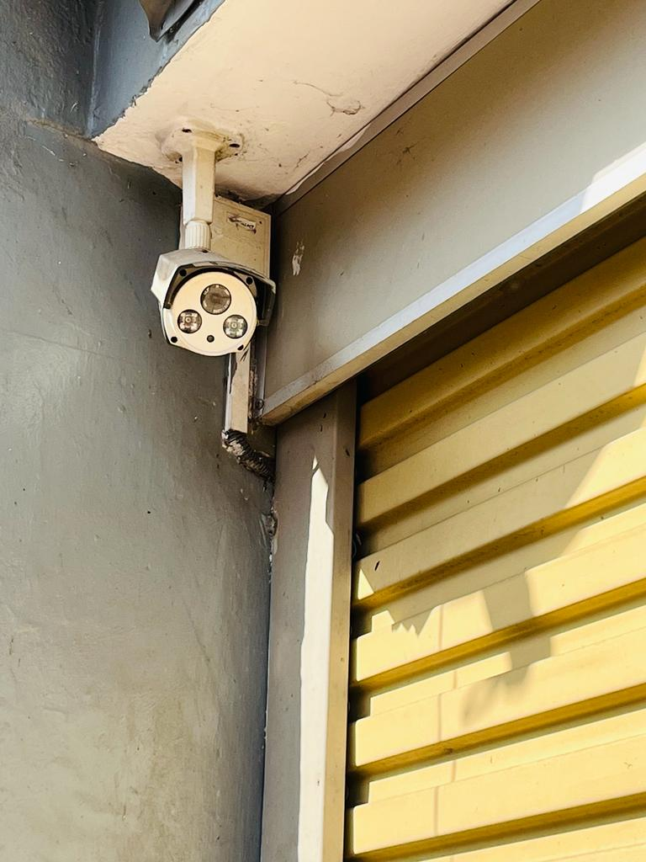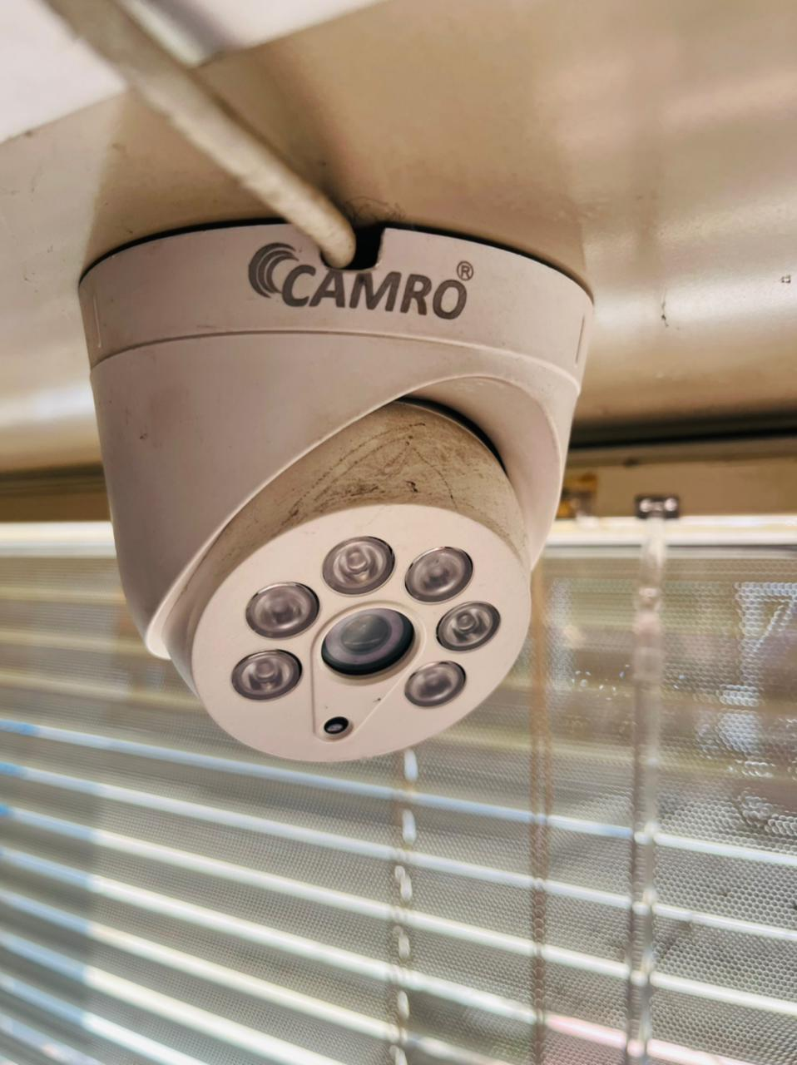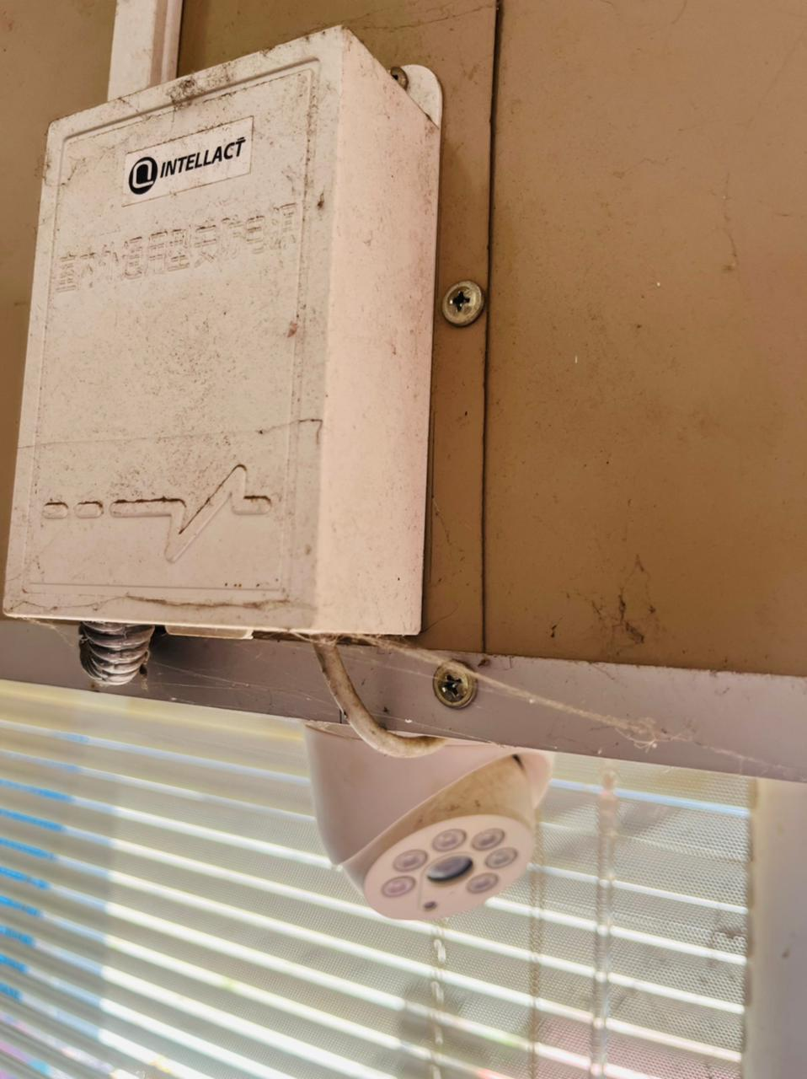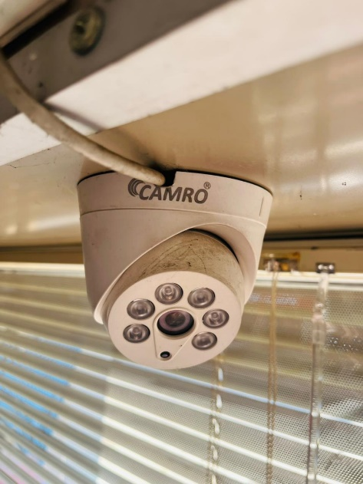

**CCTV Camera System –**

Closed-circuit television (CCTV) cameras are widely used to enhance the security and protection of people, assets and properties. It is a security force multiplier, accoutering access control, real-time surveillance and intrusion detection. CCTV Cameras also assist in the reduction of crime, larceny and vandalism for a business, property or residence. Investing in maintaining a CCTV Camera System will help apperceive safety and protection in a higher caliber. It is important to note that attempted break-ins, burglaries happen at night, under the cover of darkness. Properties that do not maintain CCTV Camera Systems are always susceptible to less homeland security.

**Strengths -**

* One of the most unprecedented benefits of having a CCTV System installed in your home is the possibility to feel safe and secure. It would be possible to remotely monitor activities and keep records of individuals that are entering and leaving the premises, including other multitudinous occurrences. CCTV recordings are effectively beneficial and invaluable to the detection of burglaries and the depletion of criminal offence investigations, making it easier to gather evidence. In case if your home is broken into and a crime does occur, it is more than possible to see and capture the unravelment of entire incident via CCTV. This would greatly assist in revealing the suspects that were involved in an incident, location of incident, transpiration of events, location of event, etc.

**The shortcomings:**

* In CCTV Cameras, it is likely for motion detection to not be as effective due to certain whether conditions like thunderstorms. The sensors may not work properly due to water seeping in and getting trapped in the system. Weather disruptions are also a considerable rationale when it comes to determining the quality of the security footage. Rain, moisture, severe winds and even heat can insinuate failures and disturbances to the system. Rain droplets can also provoke the diminishment of the camera sensor’s performance. This is due to the absorption and dispersion of falling raindrops. Furthermore, heavy downpour can cause the sensors to accidentally detect movement. This is because it may confuse rain droplets for something else. Moreover, CCTV camera footage is infallibly vulnerable to the risk of hacking and for the most part, this would point towards privacy issues.

**Two possible improvements:**

1. **Set Up And Configuration**

~ Positioning – are cameras facing the correct means while not blockages?

~ Pixels – are there enough pixels on the target, standing still and moving?

~ Shutter speed – don’t think about manufacturing factory defaults, it must be quick enough to capture and freeze movement.

1. **Maintenance And Proactive Monitoring**

Yearly mating is just not enough. You need to confirm your CCTV system is often maintained, the smallest amendment will build the largest distinction. as an example, if a camera is obscured whereas improvement, however would you recognize if it’s still capturing something useful? Or a hard drive failure?

Notifications will be found out in order that emails are sent to advise you upon video loss, hard drive failure or cameras moved.

**Part B: Paddy Field irrigation System.**

Sri Lankan paddy fields significantly play a part in the contributing towards flood control, food security and groundwater enrichment.

At this moment when the water quality in the short term is in safe hands, as water and irrigation professionals it is our duty to carefully look at water management in irrigated paddy cultivation systems especially under the light of global climate change. Although prevailing management approach may enable the survival of irrigated paddy cultivation systems under hardships, climate change impacts will bring enhanced insecurity to the irrigated paddy cultivation farmers in Sri Lanka because the lack of a pragmatic approach and weak technical capabilities would cause a threat when attempting to provide evidence based sustainable solutions.

Types of sensors for Paddy field watering system

# Humidity sensor

# Agricultural Light Sensor

The Agricultural Light Sensor will play a role in controlling and keeping track of the amount of light scintillating on the paddy field. It will determine whether the plants are receiving adequate or excessive light. This sensor will permit the grow lights to be controlled based on ambient light levels.

# Temperature sensor

The temperature sensor will measure the temperature of the air and soil. It will monitor the machinery that collects the plants in addition to the plants that are already gathered. The temperature sensors will emit signals whenever the system requires minor maintenance, is underperforming, or is critically malfunctioning.

# Soil moisture sensor

Soil moisture sensors play a role in measuring the amount of moisture in the soil at any probable time. The integration of soil moisture sensors would make it much easier to schedule water supply distribution periods. An interesting feature that is coupled with soil moisture sensors is that the more of them you utilize them, the more accurate they become.

# Water level sensor

Water level and flow sensors can be used to detect any open water channel discharge. This would aid in estimating the future water availability more accurately. Groundwater level sensors can also be used for similar goals, such as maximizing the use of groundwater in agricultural applications.

# Electro-Chemical Sensors

Electrochemical sensors contribute towards providing pH and soil nutrient concentration information. It is greatly useful for precision agriculture. The sensor electrodes work by detecting particular ions within the soil. When it comes to assessing soil fertility, electrochemical approaches have proven to be effective.

1.Sensor Readings:

Paddy Field Watering System uses sensors which will be sending readings to the inbuilt Wi-Fi module, all these readings will play a major role on the proposed system. These readings will later be used in the monthly and daily statistics, which will be sent to the agriculture department for future needed evaluations and decisions to be made for the betterment of the agriculture sector as one.